How to add 20GB storage in ubuntu via LVM:

Under disk: create:
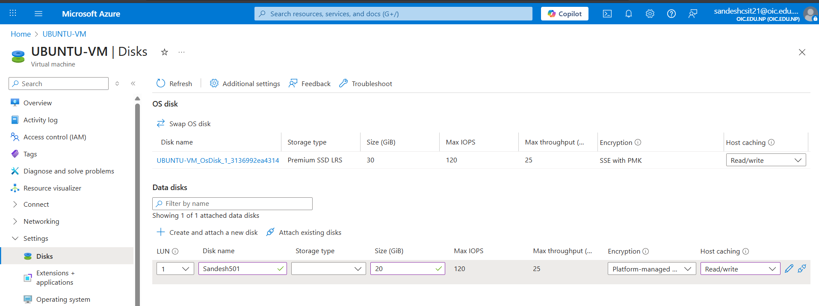

Step 1: connect to azure account:
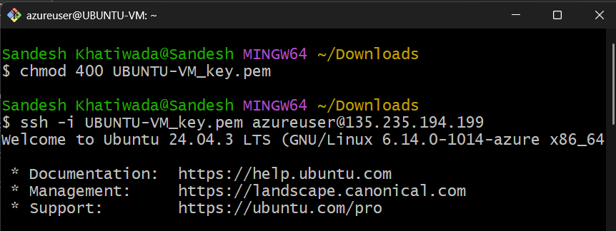

Step 2: Create Physical Volumes
- sudo pvcreate /dev/sda
- sudo pvdisplay
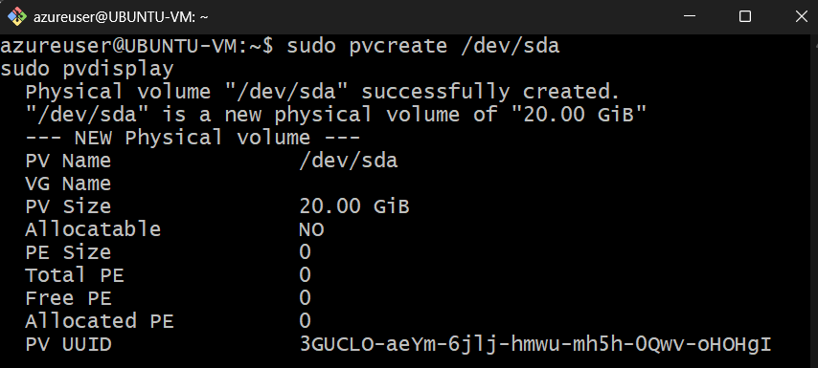
Step 2: Create a Volume Group
- sudo vgcreate ubuntu-vg /dev/sda
- Then verify it: sudo vgdisplay
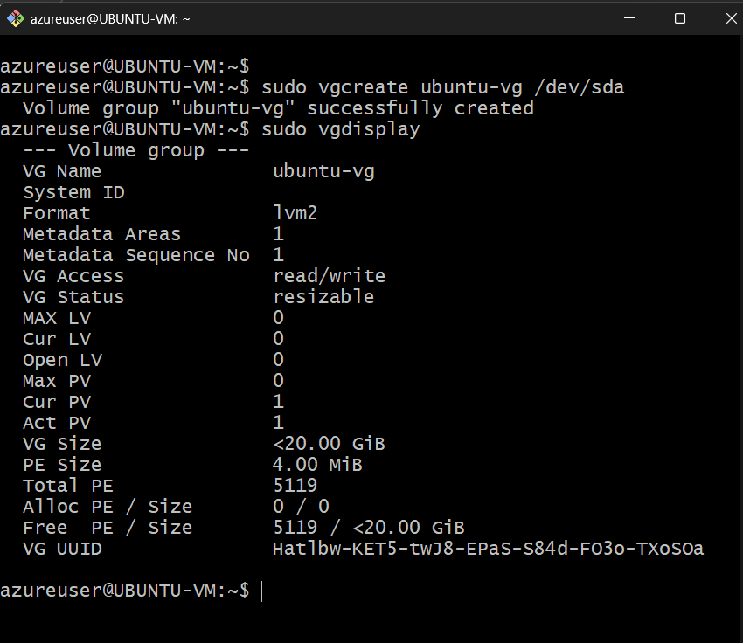
This created a Volume Group named ubuntu-vg and add your /dev/sda PV to it. The VG acts as a storage pool. The Volume Group is now a pool of 20GB storage ready to be carved into Logical Volumes.

Step 3: Create a Logical Volume
- sudo lvcreate -L 19G -n data-lv ubuntu-vg
- Then verify it: sudo lvdisplay
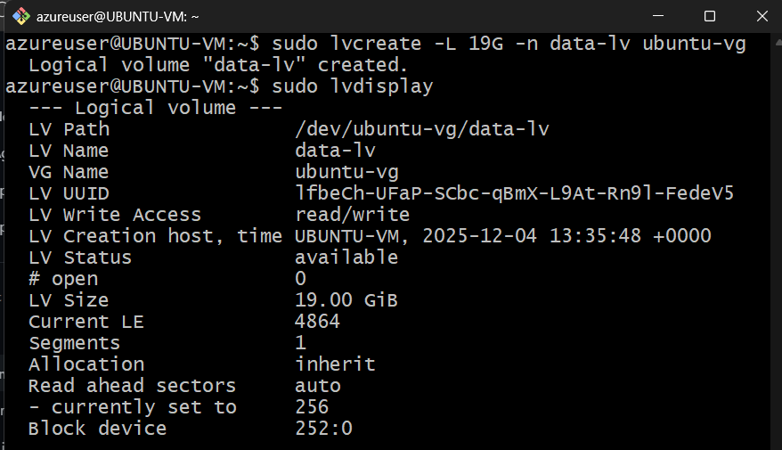
This created a Logical Volume named data-lv with 19GB from the ubuntu-vg pool (leaving ~1GB free for safety/metadata).
Step 4: Format the Logical Volume
- sudo apt update
- sudo apt install e2fsprogs -y
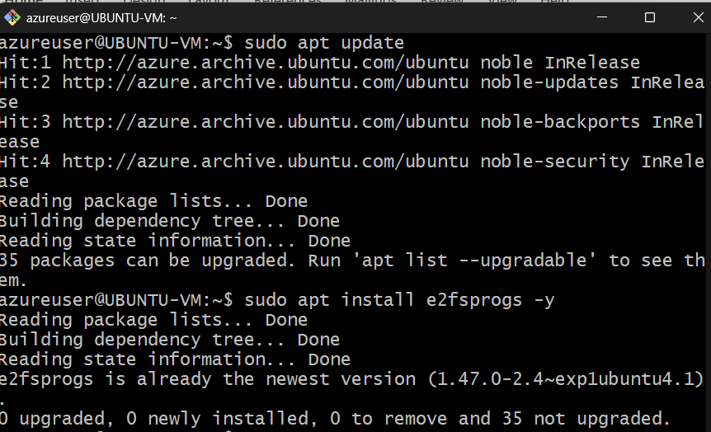
- sudo mkfs.ext4 /dev/ubuntu-vg/data-lv
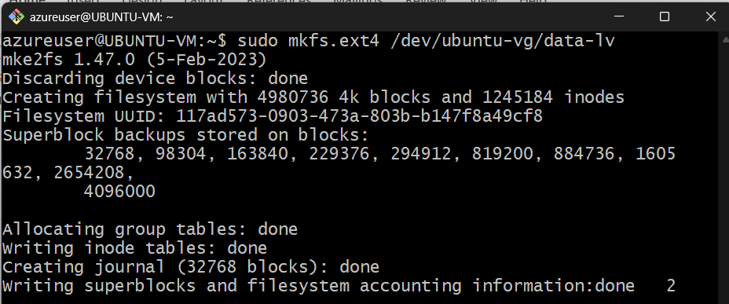
This creates an ext4 filesystem on the logical volume so you can store files on it.

Step 5: Create a mount point and mount it
- sudo mkdir -p /mnt/lvm-data
- sudo mount /dev/ubuntu-vg/data-lv /mnt/lvm-data
- Then verify it's mounted: df -h | grep lvm
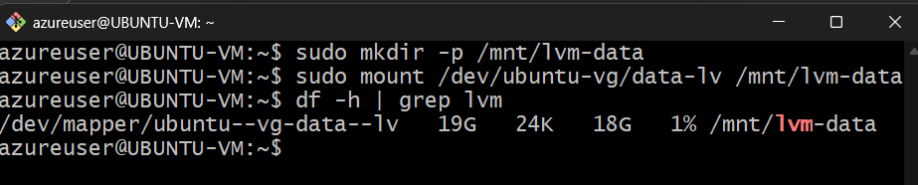
This created a directory at /mnt/lvm-data and mounts your LVM volume there.

Step 6: Make the mount permanent
- Add it to /etc/fstab so it mounts automatically on reboot:
  - echo '/dev/ubuntu-vg/data-lv /mnt/lvm-data ext4 defaults 0 0' | sudo tee -a /etc/fstab
- Then verify the fstab entry is correct:
  - cat /etc/fstab
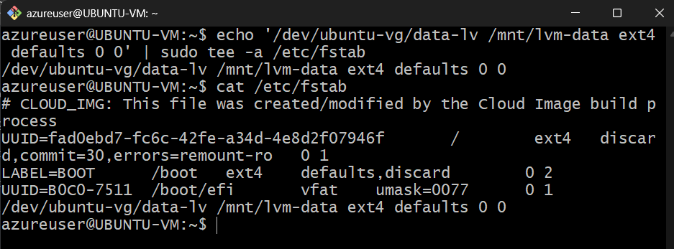

Step 7: Test the fstab entry
- Unmount and remount using fstab to ensure it works:
  - sudo umount /mnt/lvm-data
  - sudo mount -a
- Then verify it mounted correctly:
  - df -h | grep lvm
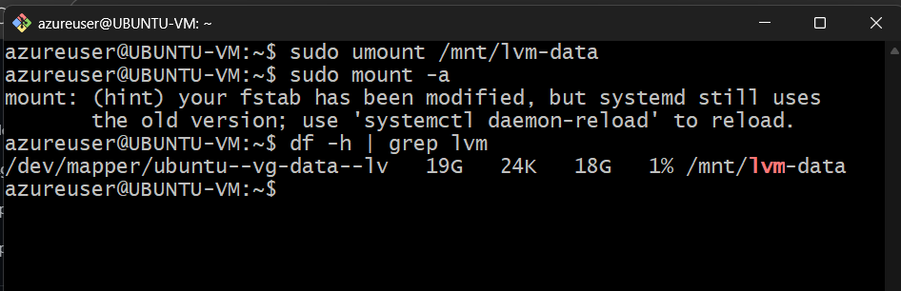
Same output as before is seem (/dev/mapper/ubuntu--vg-data--lv mounted at /mnt/lvm-data), this means it's working correctly and will survive reboots.

